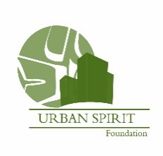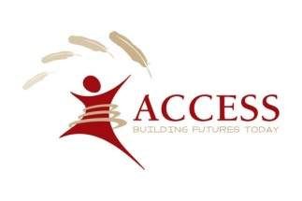
January 8, 2018

Please mark your calendars for Friday June 22, 2018! YES, it is our 6th annual ACCESS “Urban Aboriginal” Charity Golf Tournament. Early Bird Registration. Choose your preferred sponsorship level. Book your team early!

Levels of Sponsorship

Gold $10,000 (One opportunity)
- 4 Golfer registrations
- Tee Sponsor
- Prominent logo placement on promotional material pre-event
- Corporate logo recognition by MC during dinner
- Two golf Registrations for 2019 tournament

Dinner Sponsor $7,500 (One opportunity)
- 4 Golfer registrations
- Hole sponsor
- Prominent logo placement on promotional material pre-event
- Recognition throughout tournament by MC during dinner
- Corporate logo recognition

Golf Cart Sponsor $3,500 (SOLD)
- 2 Golfer registrations
- Recognition throughout tournament by MC during dinner
- Corporate logo displayed on golf carts during tournament

Corporate Hole Sponsor $500
- Hole Sponsor
- Prominent logo and sign placement
- Recognition throughout tournament and by MC during dinner

Friday June 22, 2018 at Country Meadows Golf Club, 8482 No. 6 Rd., Richmond, BC
Registration Starts at 10 AM - Shotgun Start 1:00 PM - Dinner 6:00 PM
50/50 ticket sales and silent auction and lots of Prizes!

Payments can be made by cash or cheque to:
Urban Spirit Foundation
108-100 Park Royal South
West Vancouver. BC V7T 1A2

If you have any questions please contact Elaine Clare or Gary McDermott Telephone: 604-913-7933, ext. 229
Email: elaine@urbanspiritfoundation.com or Gary McDermott Email: gary@urbanspiritfoundation.com.

Thank you for your support!

Yours truly,
John Webster
ACCESS President & CEO Urban Spirit Foundation CHARITY # 82789 5368 RR0001

